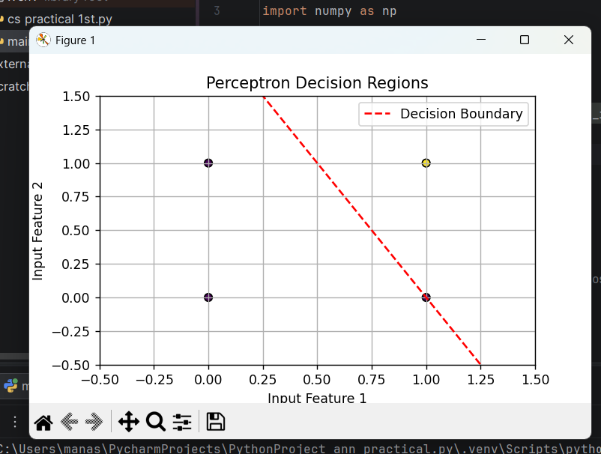

import numpy as np
import matplotlib.pyplot as plt
# 1. Define the Perceptron Class
class Perceptron:
def __init__(self, learning_rate=0.01, n_iterations=1000):
self.lr = learning_rate
self.n_iterations = n_iterations
self.weights = None
self.bias = None
def fit(self, X, y):
n_samples, n_features = X.shape
# Initialize weights and bias to zeros
self.weights = np.zeros(n_features)
self.bias = 0
# Map target labels to {0, 1}
y_ = np.where(y > 0, 1, 0)
for _ in range(self.n_iterations):
for idx, x_i in enumerate(X):
linear_output = np.dot(x_i, self.weights) + self.bias
y_predicted = self.activation_func(linear_output)
# Perceptron update rule
update = self.lr * (y_[idx] - y_predicted)
self.weights += update * x_i
self.bias += update
def activation_func(self, x):
# Step function (Heaviside)
return np.where(x >= 0, 1, 0)
def predict(self, X):
linear_output = np.dot(X, self.weights) + self.bias
y_predicted = self.activation_func(linear_output)
return y_predicted
# 2. Create an example dataset (linearly separable)
# Data points for an 'AND' gate type of problem
X = np.array([
[0, 0],
[0, 1],
[1, 0],
[1, 1]
])
# Target labels: only [1, 1] is positive (1), others are negative (0)
y = np.array([0, 0, 0, 1])
# 3. Train the Perceptron
perceptron = Perceptron(learning_rate=0.1, n_iterations=10)
perceptron.fit(X, y)
# 4. Plot the decision boundary
plt.figure(figsize=(6, 4))
plt.scatter(X[:, 0], X[:, 1], c=y, cmap='viridis', marker='o', edgecolor='k')
# Calculate the decision boundary line: w1*x1 + w2*x2 + bias = 0
# Rearranges to x2 = -(w1/w2)*x1 - (bias/w2)
w1, w2 = perceptron.weights[0], perceptron.weights[1]
bias = perceptron.bias
x1_plot = np.linspace(-0.5, 1.5, 100)
x2_plot = -(w1 / w2) * x1_plot - (bias / w2)
plt.plot(x1_plot, x2_plot, 'r--', label='Decision Boundary')
plt.xlabel('Input Feature 1')
plt.ylabel('Input Feature 2')
plt.title('Perceptron Decision Regions')
plt.legend()
plt.xlim(-0.5, 1.5)
plt.ylim(-0.5, 1.5)
plt.grid(True)
plt.show()

